
DOI: https://doi.org/10.38035/
https://creativecommons.org/licenses/by/4.0/(size 10)
enter 1 x
Title: Font Times New Roman, Size 16, Capital Each Word, left align, bolds
enter 1 x
enter 1 x
Author¹, Author², Author³, etc. (full name, not abbreviated, without a title, size 12)
¹Institutions, Regions, Countries, email. (size 11)
²Institutions, Regions, Countries, email.
³Institutions, Regions, Countries, email.
enter 1 x
Corresponding Author: email¹
enter 1 x
Abstract: Abstracts are written in one paragraph using standard Indonesian with enhanced spelling. Maximum 200 words, using Times New Roman font size 12, space 1, Italic. Contains a brief description of the overall results of the study including background issues, objectives, methods, results and conclusions. Avoid writing bibliography citations, as well as abbreviations in the abstract. The abstract contains the title of the article, research object, objectives, methods and results. Abstracts written in Bahasa and English (time new roman, size 12, space 1)
enter 1 x
Keyword: Consists of 3-5 keywords, keyword 1, keyword 2, etc.
enter 1 x
enter 1 x

INTRODUCTION
The introduction contains the research background in a concise, concise, and clear manner; research purposes; as well as supporting theories. Written in Times New Roman font, size 12, space 1. Writing in a foreign language is typed in italics. In narrative writing, no need to be given a special subtitle. Included in the writing of operational definitions, if deemed necessary, also written narratively. All forms of reference used must be written down the source. Writing citations or references using body notes, namely by writing the last name of the author and the year of writing written in brackets (Muthmainnah, 2017). (Time New Romance, size 12, space 1)
The problem formulation contains article questions that must be explained in the discussion and answered in the conclusion.
enter 1 x

METHOD
The research method contains the type of research, sample and population or research subjects, time and place of research, instruments, procedures, and research techniques, as well as other matters relating to the method of research. This section can be divided into several sub-chapters, but no numbering is necessary.
enter 1 x

RESULTS AND DISCUSSION
This section contains data (in brief form), data analysis, and interpretation of the results. Results can be presented in tables or graphs to clarify the results verbally because sometimes the display of an illustration is more complete and informative than the display in narrative form.
This section must answer the problems or research hypotheses that have been formulated previously.
enter 1 x

CONCLUSION
The conclusion must be linked to the title and answer the research formulation or objectives. Do not make statements that are not adequately supported by your findings. Write down improvements made to industrial engineering or science in general. Don't create further discussion, repeat abstracts, or simply list research findings. Don't use bullet points, use paragraph sentences instead.
enter 1 x
REFERENSI
Reference is a list of information cited in a text that is identified and taken by the author and is sourced from books and scientific articles. The information cited is from accurate and genuine sources. Consistency in references allows readers to focus on the original content of the article.
References must be presented in full and in accordance with the information cited in the contents of the article. The reference list must be arranged alphabetically (A to Z) and written last, with the concept of the American Psychological Association (APA) or by using the Mendeley application.

&&&

DESCRIPTION OF TABLES AND FIGURES

Table
Description Place the table at the top of the table. The description is written in the middle with a distance of 1 space from the table. As with the description of the figure, the table description is also numbered sequentially. Writing table sources are Placed below the table and aligned with the left margin of the table in Times New Roman font size 10. Writing in the table is typed with a single space. Horizontal lines are prioritized for table lines while vertical lines are omitted.
enter 1 x
Table 1. Teacher-student ratios in three provinces (Yogyakarta, Jakarta and Papua)
based on the level of education in 2015
Prov | SD | SMP | SMA | SMK
Yogyakarta | 1:13 | 1:12 | 1:10 | 1:10
Jakarta | 1:19 | 1:16 | 1:13 | 1:13
Papua | 1:29 | 1:15 | 1:12 | 1:09
Source: Research data
enter 1 x

Figure
Images are placed in the center (center) and referred to in the text (in line with the text). Captions for pictures are written under the pictures and numbered. Figure captions begin with an uppercase letter. If the description of the image is more than 1 line, it is written with a space of 1. If the image is a reference, then the source of the reference is also written. Image reference sources are typed in Times New Roman font size 10.
enter 1 x
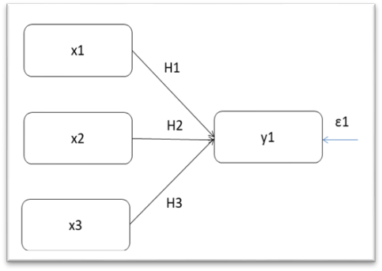
Source: Research Results (size 10, center)
Figure 1. Conceptual Framework (size 10, bold, center)
enter 1 x

&&&

BLUE COLOR SECTIONS OR SUB MANUSCRIPTS

The blue color is part or sub-chapter of the article manuscript) as shown in the image below

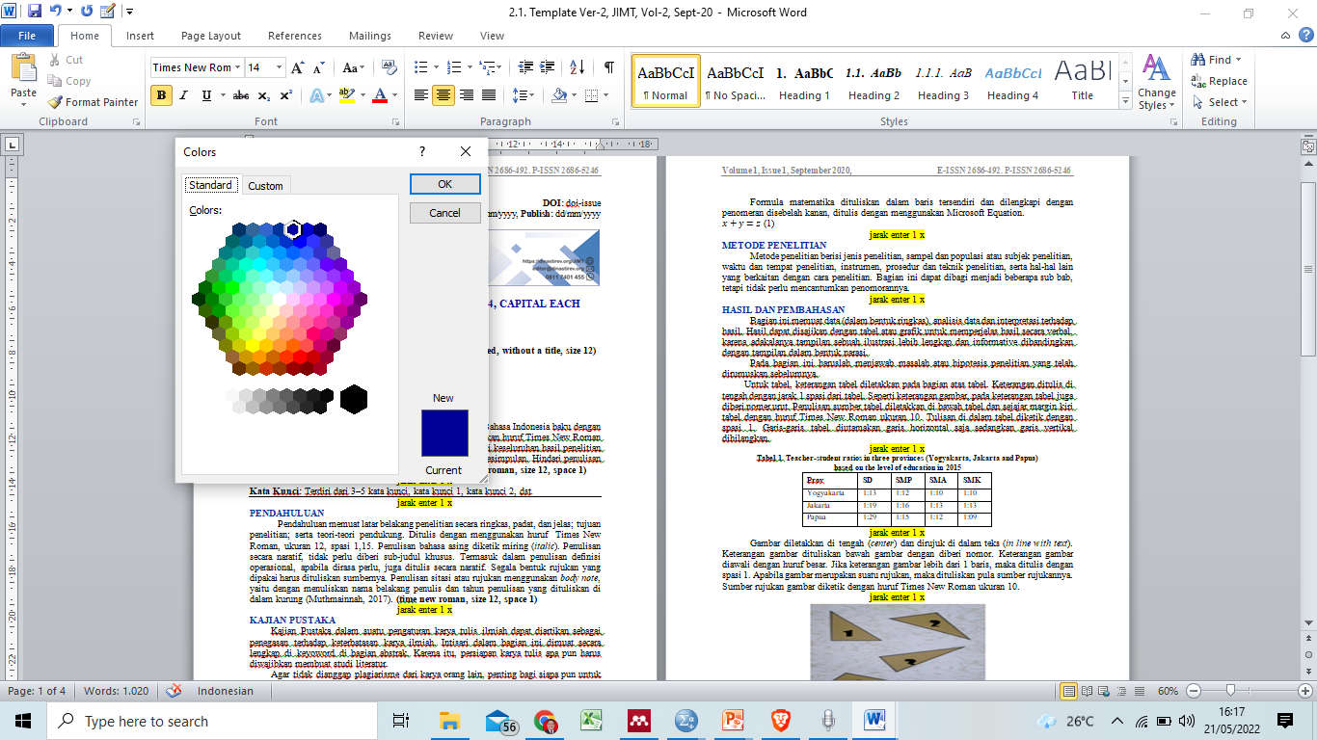

FOOTER ATAU PENOMORAN HALAMAN MANUSCRIPT

Footer and page numbering of manuscripts (articles) use: Accent Bar 2. The tutorial is (Inset➔ Page Number➔Bottom Page➔Accent Bar 2.

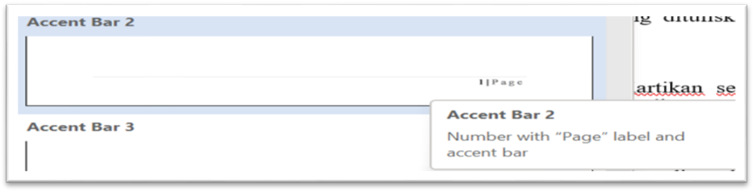

NOTE
- A4 paper
- Standard margins (top-bottom-right-left= 2.54)
- Black letter or text color
- The color of the letters or text of the section or sub-chapter is blue, as shown in the example in this template and attached below.
- 1 Space,
- Font type time new romance,
- Manuscript font size 12
- Font size for table and figure titles 10
- Font size contents of tables and figures 10
- Header and footer font size 10
- Spacing between paragraphs (spacing before and after) = 0
- The distance between sub-chapters or sections 1 x enter
- Number of pages 7-15 pages:
  - Abstract and Introduction (maximum 25%),
  - Method (maximum 15%),
  - Results and Discussion (minimum 40%),
  - Conclusions and References (maximum 20%).
- Do not use numbering, apart from numbers 1,2,3, and so on other than the formulation of the problem, discussion, and conclusion. Example: 1. aaaaa; 2. bbbbb; 3. ccccc; etc.
- If you use a number other than the formulation, discussion and conclusion, you must use a different number from the formulation, discussion and conclusion. Example: a). pppppp; b). qqqqq; c). rrrrr; etc.
- References use the concept or style of the American Psychological Association (APA).
- Font type Header and Footer time new romance, font size 11
- Explanations in yellow and these note are removed from the manuscript (article)
- Manuscripts that do not conform to the format and template will be rejected
- Isi artikel yg di publikasi pada Jurnal Pendidikan Siber Nusantara (JPSN) di luar tanggung jawab Penerbit
- Artikel yang di publikasi pada Siber Publisher adalah hasil penelitian tim author dan judul ini belum pernah di publikasikan pada Jurnal lain
&&&

