
DOI: https://doi.org/10.38035/sjam.v2i2
Received: June 25th, 2024, Revised: July 06th, 2024, Publish: July 30th, 2024
https://creativecommons.org/licenses/by/4.0/

Exploring the Effectiveness of Data Mining Classification Algorithms in Credit Card Fraud Detection

Rano Agustino¹, Nur Asniati Djaali², Mutia Restu Ayuningtias³
¹Universitas Mohammad Husni Thamrin Jakarta, e-mail: rano.agustino@gmail.com
²Universitas Mohammad Husni Thamrin Jakarta, e-mail: nurdjaali@gmail.com
³Universitas Mohammad Husni Thamrin Jakarta, e-mail: mutiarestu09@gmail.com

Corresponding Author: rano.agustino@gmail.com¹

Abstract: Credit card fraud is a widespread problem that impacts both individuals and companies. Data mining provides a powerful solution to not only detect but also prevent this type of fraud. This research explores this approach by utilizing data mining classification techniques to determine the potential for fraudulent credit card transactions. Data from various sources is collected and processed to extract relevant features. This research will compare 8 classification algorithms, namely Naive Bayes, Decision Trees, Artificial Neural Network, SVM, Linear Regression, Logistic Regression, LDA and Random Forest, in classifying transactions as legitimate or fake. These findings suggest that the combined use of these data mining classification methods offers a powerful tool in combating credit card fraud. To combat the problem of credit card fraud and maintain financial security for both individuals and institutions, this researcher explores the power of data mining. By using potential classification techniques, this research aims to predict fraudulent transactions on credit cards.

Keyword: Credit Card Fraud, Financial Losses, 8 Classification Algorithms

INTRODUCTION
Credit card fraud is an increasing threat plaguing individuals and financial institutions around the world. This results in significant financial losses, erodes consumer confidence, and disrupts the smooth functioning of the financial sector. To address this widespread problem and maintain financial security, researchers are actively exploring innovative solutions. This research investigates the power of data mining, a powerful weapon in the fight against credit card fraud.
This research uses classification techniques in data mining to identify potentially fraudulent transactions on credit cards. By processing datasets originating from European cardholders in January and February 2024, this research uses several classification algorithms in data mining to compare which algorithm will have the highest accuracy, precision and AUC/ROC values. The calcification algorithm used consists of Naive Bayes, Decision Trees, and Random Forest, SVM, Neural Network, LDA, Logistic Regression and Linear Regression.
The purpose of this research is to compare which 8 algorithms are best for predicting potential fraudulent credit card transactions. These findings have the potential to make a significant contribution to the development of accurate and reliable models that can combat credit card fraud and improve financial security for society, especially credit card users.

Literature Review
Research conducted by Awoyemi, J. O. et all, in 2017, with the title Credit card fraud detection using machine learning techniques: A comparative analysis. Online credit card fraud is becoming a huge problem. Data mining can help detect it, but the data is imbalanced and behavior is constantly changing. This research compares 3 techniques for detecting fraud in unbalanced European credit card data: naïve Bayes, k-nearest neighbors, and logistic regression. K-nearest neighbors showed the best performance with an accuracy of 97.69%, outperforming naïve Bayes (97.92%) and logistic regression (54.86%). This work is performed in Python and evaluates performance based on accuracy, sensitivity, specificity, precision, Matthews correlation coefficient, and balanced classification rate.
The next research was in 2019 by Varmedja, D et all., with the article title Credit card fraud detection-machine learning methods. This research examines how online credit card fraud continues to increase and challenges fraud detection due to changing behavior and data imbalances. This research compares the performance of Naïve Bayes, K-Nearest Neighbor, and Logistic Regression on imbalanced credit card data. Under-sampling and over-sampling techniques are applied to raw data and processed data. K-Nearest Neighbor showed the best performance with an accuracy of 97.69%, outperforming Naïve Bayes (97.92%) and Logistic Regression (54.86%). Conclusion: K-Nearest Neighbor is more effective for detecting credit card fraud in imbalanced data.
The next research was conducted by Singh, P., et all in 2024, entitled Anomaly Detection Classifiers for Detecting Credit Card Fraudulent Transactions, examined credit card fraud which has increased with the rapid internet and e-commerce. Anomaly Detection, using advanced algorithms, is emerging as a solution to identify fraudulent transactions. This research compares two algorithms - Isolation Forest (IF) and Local Outlier Factor (LOF) - to detect anomalies in imbalanced credit card datasets. The results show that IF achieves the highest accuracy (99.81%) on European data, while LOF with Random Undersampling achieves 70.60% accuracy on German data.

METHOD
Our research methodology employs a quantitative approach. The data processing method utilized is CRISP-DM (Cross-Industry Standard Process for Data Mining). This framework involves the following stages:
- Business Understanding: This stage focuses on comprehending the business objectives of the project, which in this case is to predict fraudulent credit card transactions.
- Data Understanding: The research utilizes secondary data obtained from European cardholders in January 2024 only. This dataset comprises 900 records with variables detailed in the following table 1. dataset.

table 1. dataset
Id | Unique identifier for each transaction
V1-V28 | Anonymized features representing various transaction attributes (e.g., time, location, etc.)
Jumlah | The transaction amount
Penipuan | Binary label indicating whether the transaction is fraudulent (Ya) or not (Tidak)

- Data Preparation Prepare the dataset so that it is clean and has no errors and is redundant so that later when it is used at the modeling stage it can run well
- Model Making (Modeling)Select eight appropriate algorithms based on the research objective, namely data classification. 8 Algorithms consist of Naive Bayes, Decision Trees, and Random Forest, SVM, Neural Network, LDA, Logistic Regression and Linear Regression.
- Model Evaluation (Evaluation)In this process, 8 algorithms will be compared by looking at the resulting values of Accuracy, Precision and AUC. In this process, the dataset is also divided (training data and testing data) and then it is tested for 10 tests or often called 10 Validations or also Cross Validation or also X - Validation. For more details, you can see the following picture.

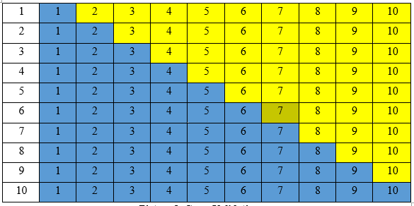
Picture 1. Cross Validation

RESULTS AND DISCUSSION
Following data acquisition, a Data Understanding process is conducted. During this stage, researchers explore the dataset to identify patterns and potential fraudulent credit card transactions. Eight algorithms will be compared for their effectiveness in fraud detection: Naive Bayes, Decision Trees, Random Forest, SVM, Neural Network, LDA, Logistic Regression, and Linear Regression. The chosen evaluation metrics include accuracy, precision, and AUC (Area Under the ROC Curve). Before proceeding to the Modeling stage, a Data Preparation process is crucial to ensure the dataset is clean and suitable for modeling. The Modeling stage involves dividing the data for testing purposes into training and testing sets. A 10-fold cross-validation approach is employed, where the data is split into 10 subsets, with each fold used for testing once while the remaining folds are used for training.
Following the Data Preparation stage, the Modeling stage commences. This research utilizes the Rapidminer tool to perform the modeling of the eight aforementioned algorithms.
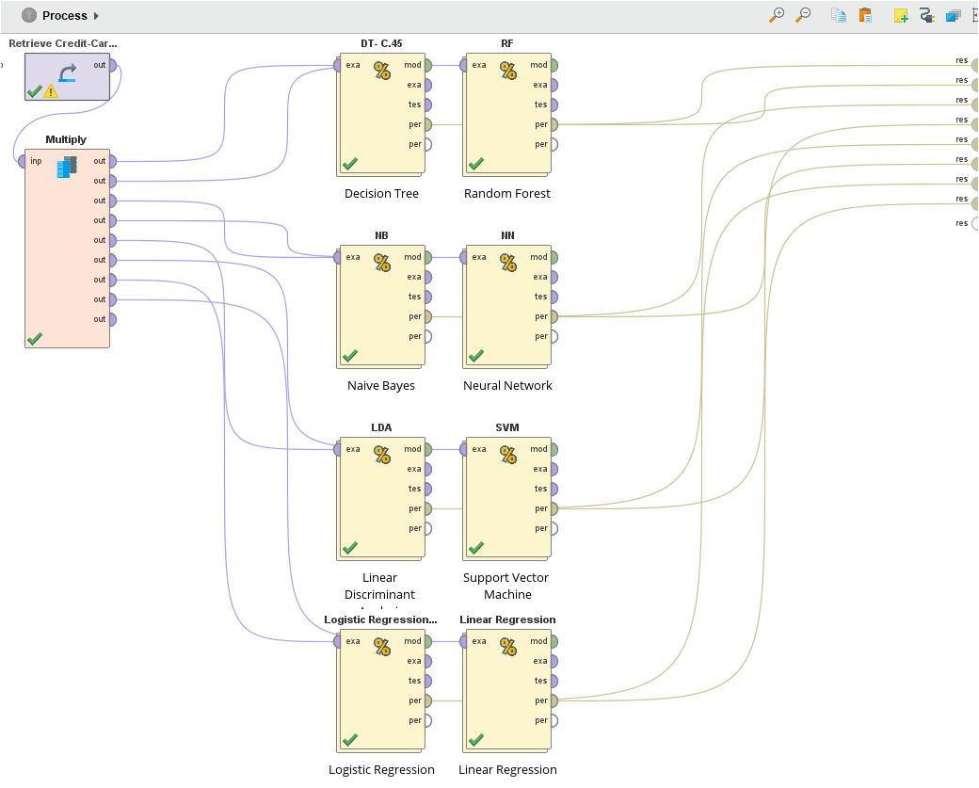
Picture 2. Modeling Stages

Following the modeling process, the resulting accuracy, precision, and AUC values are presented in the following table 2. Evaluasi;

table 2. Evaluasi
Algoritma | Accuracy | Precision | AUC/ROC | Average
Decision Tree | 94.22 % | 99.16 % | 84.3 % | 92.56
Random Forest | 94.22 | 97.35 % | 97.6 % | 96.39
Naive Bayes | 92.67 % | 94.92 % | 96.2 % | 94.59
Neural Network | 95.00 % | 95.92 % | 97.8% | 96.42
LDA | 94.22 % | 98.33 % | 0 | 64.18
SVM | 94.56 % | 97.09 % | 97.8 % | 96.48
Logistic Regression | 95.22 % | 96.97 % | 97.5 % | 96.56
Linear Regression | 94.33 % | 97.61 % | 97.8 % | 96.58

CONCLUSION
Based on the research findings, we can conclude the following:
- Neural Network, SVM, and Linear Regression emerge as the most effective algorithms for predicting credit card fraud. These three algorithms share the highest AUC/ROC value of 97.8%, indicating their superior ability to distinguish between legitimate and fraudulent transactions.
- Logistic Regression boasts the highest accuracy (95.22%), suggesting its strong capability for accurate transaction prediction. However, its precision falls short of the Decision Tree algorithm.
- The Decision Tree algorithm takes the lead in precision (99.16%), demonstrating its effectiveness in correctly identifying fraudulent transactions. However, its accuracy is surpassed by Logistic Regression.
- Among the algorithms evaluated, Linear Regression emerged as the most suitable for predicting fraudulent credit card transactions. This conclusion is based on its highest average value, reaching 96.58.
Acknowledgement
The author would like to thank Mohammad Husni Thamrin University which has played a role in this research both in terms of financial and moral support so that this publication can be achieved. The author also would like to thank the organizing committee of the Bhayangkara Multidisciplinary International Conference (BMIC) for providing facilities at the international journal conference.

Conflict of Interest
We certify that no conflict of interest exists regarding the publication of this manuscript. All financial and personal relationships that could potentially bias or influence our research have been disclosed fully.

REFERENCE
Abiodun, O. I., Jantan, A., Omolara, A. E., Dada, K. V., Mohamed, N. A., & Arshad, H. (2018). State-of-the-art in artificial neural network applications: A survey. Heliyon, 4(11).
Agustino, R. (2019). Komparasi Algoritma Klasifikasi Dengan Menggunakan Anaconda untuk Memprediksi Ramai Penonton Film di Bioskop. Jurnal Teknologi Informatika dan Komputer, 5(1), 24-28.
Awoyemi, J. O., Adetunmbi, A. O., & Oluwadare, S. A. (2017, October). Credit card fraud detection using machine learning techniques: A comparative analysis. In 2017 international conference on computing networking and informatics (ICCNI) (pp. 1-9). IEEE.
Bagga, S., Goyal, A., Gupta, N., & Goyal, A. (2020). Credit card fraud detection using pipeling and ensemble learning. Procedia Computer Science, 173, 104-112.
Bakhtiari, S., Nasiri, Z. & Vahidi, J. Credit card fraud detection using ensemble data mining methods. Multimed Tools Appl 82, 29057–29075 (2023). https://doi.org/10.1007/s11042-023-14698-2.
Bin Sulaiman, R., Schetinin, V., & Sant, P. (2022). Review of machine learning approach on credit card fraud detection. Human-Centric Intelligent Systems, 2(1), 55-68.
Botchey, F. E., Qin, Z., & Hughes-Lartey, K. (2020). Mobile money fraud prediction—a cross-case analysis on the efficiency of support vector machines, gradient boosted decision trees, and naïve bayes algorithms. Information, 11(8), 383.
Carcillo, F., Le Borgne, Y. A., Caelen, O., Kessaci, Y., Oblé, F., & Bontempi, G. (2021). Combining unsupervised and supervised learning in credit card fraud detection. Information sciences, 557, 317-331.
Carrington, A. M., Fieguth, P. W., Qazi, H., Holzinger, A., Chen, H. H., Mayr, F., & Manuel, D. G. (2020). A new concordant partial AUC and partial c statistic for imbalanced data in the evaluation of machine learning algorithms. BMC medical informatics and decision making, 20, 1-12.
Carrington, A. M., Manuel, D. G., Fieguth, P. W., Ramsay, T., Osmani, V., Wernly, B., ... & Holzinger, A. (2022). Deep ROC analysis and AUC as balanced average accuracy, for improved classifier selection, audit and explanation. IEEE Transactions on Pattern Analysis and Machine Intelligence, 45(1), 329-341.
Charitha, S., Chowdary, S., Rao, T., Kodipalli, A., Kamal, S., Rohini, B.R. (2024). Credit Card Fraud Analysis Using Machine Learning. In: Shetty, N.R., Prasad, N.H., Nagaraj, H.C. (eds) Advances in Communication and Applications. ERCICA 2023. Lecture Notes in Electrical Engineering, vol 1105. Springer, Singapore. https://doi.org/10.1007/978-981-99-7633-1_21
Fadhli, A., & Warman, A. B. (2021). ‘Alasan Khawatir’ Pada Penetapan Hukum Dispensasi Kawin Di Pengadilan Agama Batusangkar ‘Reasons for Concern’ on Marriage Dispensation Decisions in Batusangkar Religious Court. Al-Ahwal, 14(2), 146–158. https://doi.org/10.14421/ahwal.2021.14203
Jiang, C., Song, J., Liu, G., Zheng, L., & Luan, W. (2018). Credit card fraud detection: A novel approach using aggregation strategy and feedback mechanism. IEEE Internet of Things Journal, 5(5), 3637-3647.
Kamali, M. H. (2020). Actualization (Taf’il) of the Higher Purposes (Maqasid) of Shariah. International Institute of Advanced Islamic Studies (IAIS).
Lakshmi, S. V. S. S., & Kavilla, S. D. (2018). Machine learning for credit card fraud detection system. International Journal of Applied Engineering Research, 13(24), 16819-16824.
Makki, S., Assaghir, Z., Taher, Y., Haque, R., Hacid, M. S., & Zeineddine, H. (2019). An experimental study with imbalanced classification approaches for credit card fraud detection. IEEE Access, 7, 93010-93022.
Maniraj, S. P., Saini, A., Ahmed, S., & Sarkar, S. (2019). Credit card fraud detection using machine learning and data science. International Journal of Engineering Research, 8(9), 110-115.
Muschelli III, J. (2020). ROC and AUC with a binary predictor: a potentially misleading metric. Journal of classification, 37(3), 696-708.
Narkhede, S. (2018). Understanding auc-roc curve. Towards data science, 26(1), 220-227.
Nasution, K. (2005). Women’s Right in the Islamic Family Law of Indonesia. Unisia, 28(56), 192–204. https://doi.org/10.20885/unisia.vol28.iss56.art10
Priscilla, C. V., & Prabha, D. P. (2020). Credit card fraud detection: A systematic review. In Intelligent Computing Paradigm and Cutting-edge Technologies: Proceedings of the First International Conference on Innovative Computing and Cutting-edge Technologies (ICICCT 2019), Istanbul, Turkey, October 30-31, 2019 1 (pp. 290-303). Springer International Publishing.
Roy, A., Sun, J., Mahoney, R., Alonzi, L., Adams, S., & Beling, P. (2018, April). Deep learning detecting fraud in credit card transactions. In 2018 systems and information engineering design symposium (SIEDS) (pp. 129-134). IEEE.
Sailusha, R., Gnaneswar, V., Ramesh, R., & Rao, G. R. (2020, May). Credit card fraud detection using machine learning. In 2020 4th international conference on intelligent computing and control systems (ICICCS) (pp. 1264-1270). IEEE.
Shirodkar, N., Mandrekar, P., Mandrekar, R. S., Sakhalkar, R., Kumar, K. C., & Aswale, S. (2020, February). Credit card fraud detection techniques–A survey. In 2020 International Conference on Emerging Trends in Information Technology and Engineering (ic-ETITE) (pp. 1-7). IEEE.
Singh, P., Singla, K., Piyush, P., & Chugh, B. (2024, January). Anomaly Detection Classifiers for Detecting Credit Card Fraudulent Transactions. In 2024 Fourth International Conference on Advances in Electrical, Computing, Communication and Sustainable Technologies (ICAECT) (pp. 1-6). IEEE.
Smith, S. C. (2011). Crowdsourcing sharia: Digital fiqh and changing discourses of textual authority, individual reason, and social coercion. Georgetown University.
Thennakoon, A., Bhagyani, C., Premadasa, S., Mihiranga, S., & Kuruwitaarachchi, N. (2019, January). Real-time credit card fraud detection using machine learning. In 2019 9th International Conference on Cloud Computing, Data Science & Engineering (Confluence) (pp. 488-493). IEEE.
Varmedja, D., Karanovic, M., Sladojevic, S., Arsenovic, M., & Anderla, A. (2019, March). Credit card fraud detection-machine learning methods. In 2019 18th International Symposium INFOTEH-JAHORINA (INFOTEH) (pp. 1-5). IEEE.
Xuan, S., Liu, G., Li, Z., Zheng, L., Wang, S., & Jiang, C. (2018, March). Random forest for credit card fraud detection. In 2018 IEEE 15th international conference on networking, sensing and control (ICNSC) (pp. 1-6). IEEE.
Zou, X., Hu, Y., Tian, Z., & Shen, K. (2019, October). Logistic regression model optimization and case analysis. In 2019 IEEE 7th international conference on computer science and network technology (ICCSNT) (pp. 135-139). IEEE.
Robles-Velasco, A., Cortés, P., Muñuzuri, J., & Onieva, L. (2020). Prediction of pipe failures in water supply networks using logistic regression and support vector classification. Reliability Engineering & System Safety, 196, 106754.
Salazar, A., Safont, G., & Vergara, L. (2018, July). Semi-supervised learning for imbalanced classification of credit card transaction. In 2018 International Joint Conference on Neural Networks (IJCNN) (pp. 1-7). IEEE.

